**CACHE API**

<https://www.srijan.net/resources/blog/the-fundamentals-of-caching-in-drupal-8>

* **Internal Page Caching:**

The Internal Page Caching module when enabled, stores the complete page information even if the user visiting the site hasn’t logged in. Future anonymous visitors will then observe that the same content is loaded extremely fast since the page wasn’t put together from scratch. This module is useful for websites with a lot of unregistered users

* **Internal Dynamic Page Cache:**

The Internal Dynamic Page Cache module is designed to cache small sections of each page for all users whether they are logged in or not. Whenever the page content is requested by the same or different user, the module can pull in those individual parts to speed up the building of the page on the fly.

1. **Cache Tags**
2. **Cache Contexts**
3. **Cache Max-Age**

Big Pipe

<https://www.zu.com/articles/caching-drupal-8>

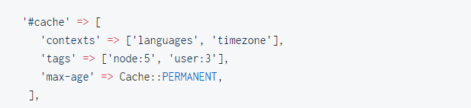

https://codeburst.io/cache-in-drupal-8-66b474a0508d